Braidburn School
School Improvement Plan Session: 2024-25
Summary Document

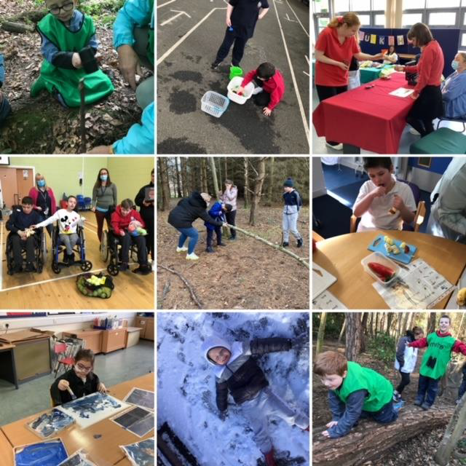

School Statement: Vision, Values & Aims, Curriculum Rationale
The Braidburn School Vision, Values and Aims were updated during Session 2023/24 and refreshed in 2024/25 in consultation with staff, pupils and parents and carers to ensure they were accessible to all our learners.

Vision
To work together to support our children and young people to feel safe, happy and ready to learn. To create an environment where our staff, pupils and families feel valued and able to contribute to the wider life of the school.
- Happy

- Respected

- Independent

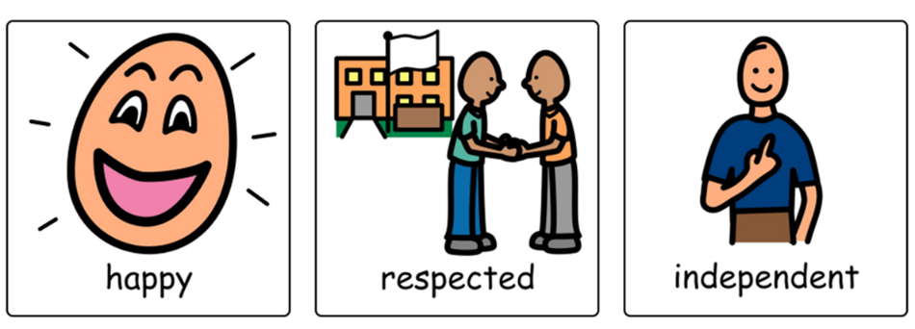

Aims

To promote independence and communication within a nurturing environment, enabling our pupils to develop their confidence.
To provide high quality learning experiences which enables pupils to learn new skills and enjoy life.

Improvement Priority 1
Priority | Excellence in Learning and Teaching
Person(s) Responsible | Head Teacher, Depute Head Teachers, Teachers and Support Staff
Next Steps from Standards and Quality Report | - Complete the review and development of the Curriculum.  - Develop a Teaching and Learning Strategy to ensure a shared and consistent approach across the school.  - Implement a clear action plan regarding next steps for the deaf community in the school.  - Develop staff understanding of approaches to inclusive communication and sensory profiling,  - Develop staff confidence, skillset and consistency in the development of individual targets.  - Development of Pupil Tracking System, in consultation with CEC.
Implementation Activities
- Create a Learning and Teaching Working Group to share and explore best practice, internally and externally.
- Present curriculum documents to the Parent Council.
- Leadership Team to create a Teaching and Learning Strategy
- Develop an overview and strategy document outlining our vision and current support for our deaf students.
- INSET day focussed on Inclusive Communication
- Development of individual targets and report writing and implementation of Pupil Tracking System.

Improvement Priority 2
Priority | Development of engagement, and leadership of learning
Person(s) Responsible | Head Teacher, Depute Head Teachers, Teachers and Support Staff
Next Steps from Standards and Quality Report | - Consider ways to model and embed the school’s Vision, Values and Aims in practice through a working group focused on  Culture and Ethos  - Review the Leadership Team roles and remits; and share these with all staff and stakeholders within the school to ensure  learners, staff, parents and carers know who to contact for help and support.  - Redevelop a new school website.

Implementation Activities
(how, when and who?)
- The remits of the school leadership team are reviewed. This should take account of the change in number of Primary and Secondary classes for Session 25/26.
- Ethos and Culture Working Group to work towards embedding school vision and values.
- Website to be populated with up to date information, consultation with Parent Council and soft launch to learning community.

