Braidburn School
School Improvement Plan Summary
Session: 2025-26

Summary Document


School Statement: Vision, Values & Aims, Curriculum Rationale
The Braidburn School Vision, Values and Aims were refreshed in 2024/25 in consultation with staff, pupils, parents, carers and the wider learning community to ensure they were accessible to all our learners.

Our Learning Community
Our Learning Community is unique, we work together in partnership with staff, our families and our health professionals to meet the diverse needs of all our young people.
Our health professionals support us with professional development and elements of school improvement, so it was important to include them in our Visions, Values, Aims refresh.
We value our partnership with parents, carers and extended families. We recognise the importance of providing opportunities to consult and discuss new ideas and initiatives together.

Our Vision
To work together to support our children and young people to feel safe, happy and ready to learn. To create an environment where our staff, pupils and families feel valued and able to contribute to the wider life of the school.

Our Values
- Happy
- Respected
- Independent

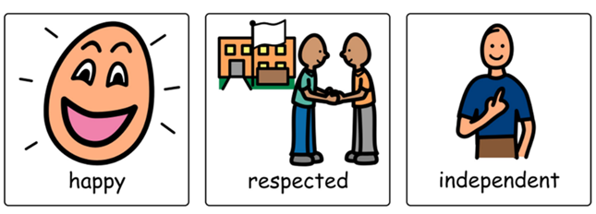

Our Aims
To promote independence and communication within a nurturing environment, enabling our pupils to develop their confidence.
To provide high quality learning experiences which enables pupils to learn new skills and enjoy life.

Braidburn School Curriculum Rationale

Braidburn learners have a range of complex, long term additional support needs and therefore require a significantly modified learning environment. The needs of the learners are primarily associated with physical and intellectual disability (with or without autism spectrum disorder), and significant visual/sensory, health and medical needs.

Our curriculum
- Our Curriculum is embedded within 3 core principles that will be experienced by all learners.
- Our core principles underpin the 4 capacities of successful learning, growing confidence, building responsibilities and supporting contribution within society
- Learners will be supported to access 4 learning pathways on their learning journey.

These will provide a flexible, progressive framework of high quality, individualised experiences.
- This education journey will be planned and evaluated in partnership with families and wider partners.

Purpose
- To ensure high quality opportunities for development and learning in preparation for life, learning and enjoyment, now and beyond school.
- To maintain a positive, solution focused ethos where we work together to support every child and young person to feel safe, show feelings and share views.
- To promote independence and communication within an empathetic and nurturing environment so young people leave school the confidence and skills to enjoy life.

The structure of our curriculum: Learning Pathways

Through assessment, moderation and tracking, learners will encounter learning
experiences on their individualised pathways. The wider context for learning provides a flexible education journey within a broader Curriculum for Excellence framework, where learners can move between the pathways according to changing need.
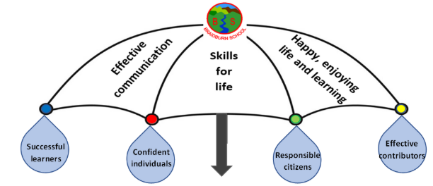

Improvement Priority 1

Priority | Excellence in Learning and Teaching
Person(s) Responsible | Head Teacher, Depute Head Teachers, Teachers and Support Staff
Next Steps from Standards and Quality Report | To continue to develop the curriculum offer across the school.  To develop a Teaching and Learning Strategy which reflects the diverse range of pupil need at Braidburn School and includes guidance on Deaf Support withing the school.  To develop a digital platform for tracking and monitoring of pupil progress in literacy and numeracy over time, which is consistent across the school (in consultation with CEC).  To review GIRFEC processes, the reporting of pupil progress and provide updated guidance to staff, parents and carers and the wider school community.

Improvement Priority 2
Priority | Development of engagement, and leadership of learning
Person(s) Responsible | Head Teacher, Depute Head Teachers, Teachers and Support Staff
Next Steps from Standards and Quality Report | To promote health and wellbeing across the school, ensuring we provide opportunities for staff, pupils and the parent community to feel safe, heard and valued.  Family Support Worker will work with Parents and Carers to provide opportunities to both support and engage families in life of the school.  To increase opportunities to develop skills for learning, life and work, including access to supported work placements for our Senior Phase pupils.  To continue to develop our procedures for Transition throughout the school, with the support of our partner agencies.

